

**EE 464**

**HARDWARE PROJECT**

**48V to 24V Flyback Converter**

**Design and Implementation**

**Team Members: Abdurrahman Aydın 1936293**

**Yusuf Basri Yılmaz 2031698**

**Olgun Erdoğan 2030567**

**Submitted to: Ozan Keysan**

**Date:08.06.2018**

# Introduction

This report provides information about design procedure and simulation results of the project assigned to our team and includes the test results obtained from the final product.

# Overall Design

As determined in project description, our converter type is fly-back converter. Aim of our circuit is converting 48 V DC to 24 V DC at 100W output. In addition, minimizing loss and controlling output voltage are also our aims of the circuit.

Some information of the circuit are given as follows;

* Input voltage= 48 V DC (25% changeable for controller)
* Output Voltage= 24 V DC (has to be constant)
* Output Power=100 W
* Output Current at Full Load= 4.16 A
* Switch Frequency = 20kHz
* Duty Cycle=0.4 at 48 V input
* N1/N2= 48/36

The overall circuit and output current and voltage simulation results are given as follows;

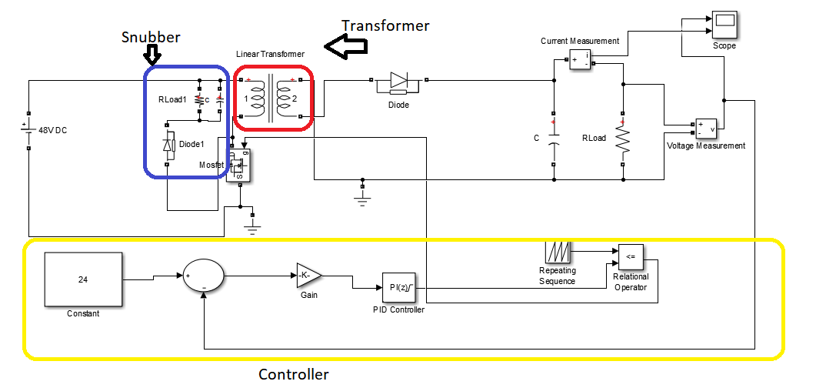

Figure 1. Overall Circuit of Flyback Converter

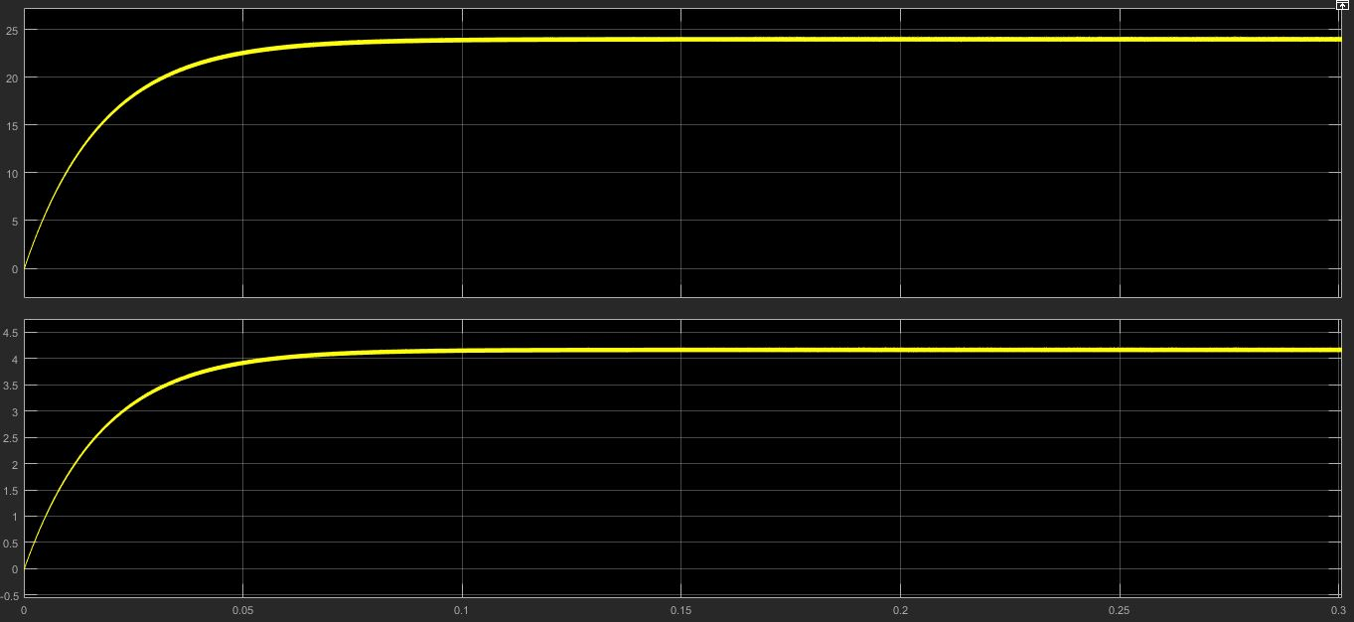

Figure 2.Simulation Result of Flyback Converter Vin=48V and Vout=24V at P=100W

The fly-back converter designed by us consists of 3 main parts.

* Transformer
* Snubber
* Controller

First part is transformer part. Transformer is using for isolation and increasing or decreasing coming voltage and current primary side. Second part is snubber. Snubber is used for decreasing voltage on MOSFET. Effects of snubber on circuit will be determined at snubber part. Last part is controller part. Controller is used for working on load types or different input voltages.

The sub-parts are given as follows;

## Transformer

Transformer parameter was determined in simulation project 2 for 250 kHz. However, 250 kHz is very high for our circuit. Therefore, we did some experiment with different frequency. As a result of these experiment, we decided to use 20 kHz. Since the most efficient results was taken at 20 kHz. The efficiency at 20 kHz was around 80%.

We chose AWG 18 wire for using transformer. Since wire current capacity is around 5A according to our system. AWG 18 current capacity is equal to 7 A.

The AWG cable current capacities are given as follows;

Table 1. AWG Cable Features Table

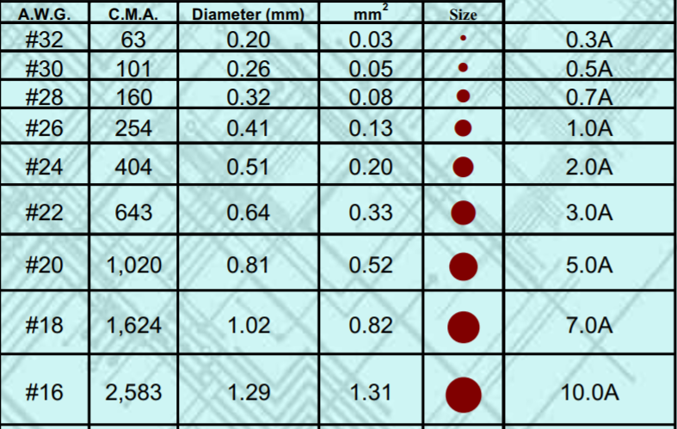

We can choose below number of AWG 19 cable. However, winding difficulty and cost are increasing with increasing diameter of wire. Therefore, we chose AWG 18.

We use ETD core as determined simulation project 2. ETD 44 core is the core used in our transformer. Calculations are same with project-2 question 1 transformer design.

Primary winding number is equal to 48 and secondary winding number is equal to 36.

The leakage inductance and magnetizing inductance changed according to winding shape and density.

The leakage and magnetizing inductances are given as follows;

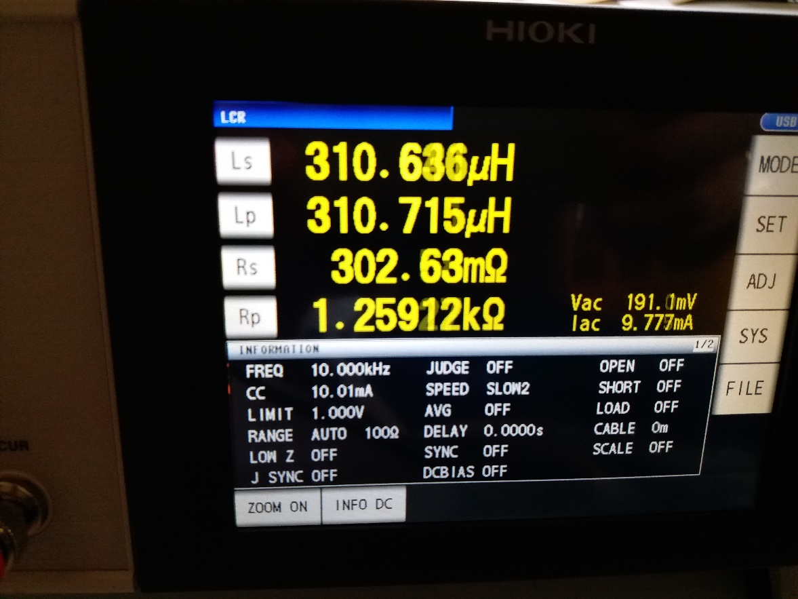

Figure 3. Magnetizing Inductance of Transformer

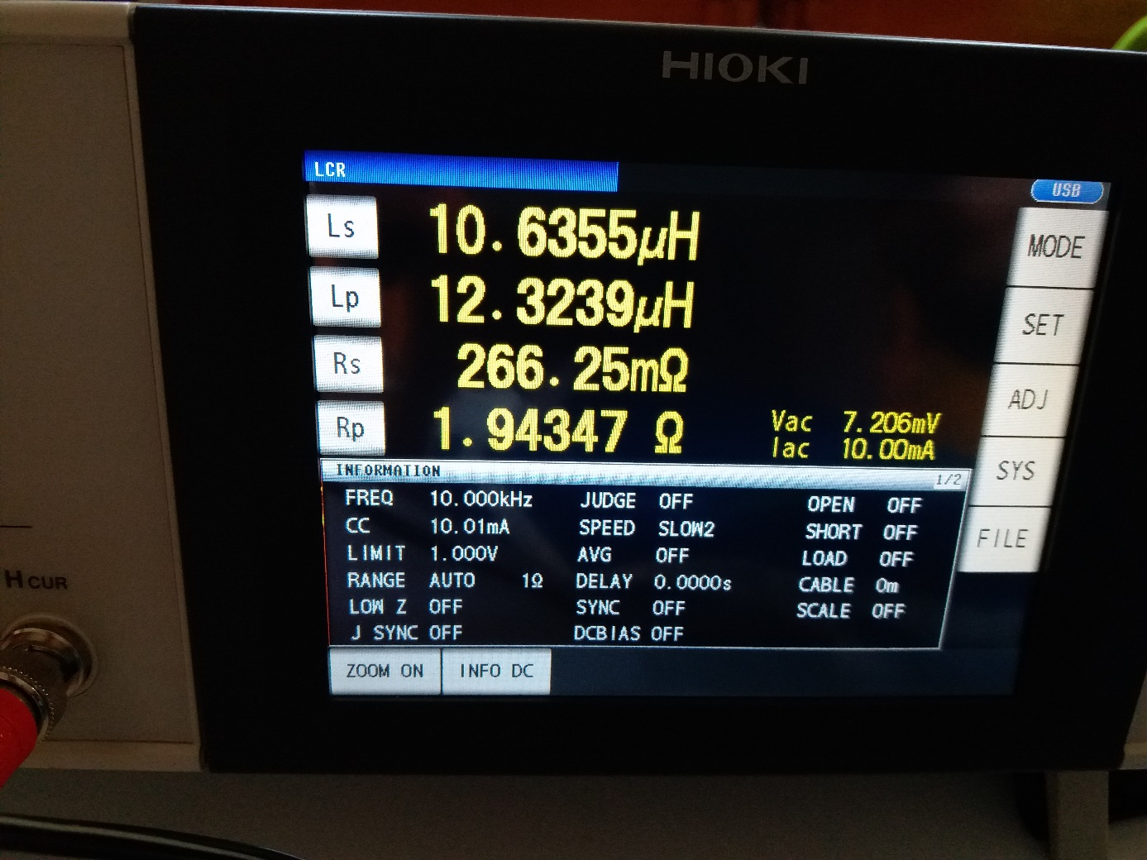

Figure 4. Leakage Inductance of Transformer at Primary Side

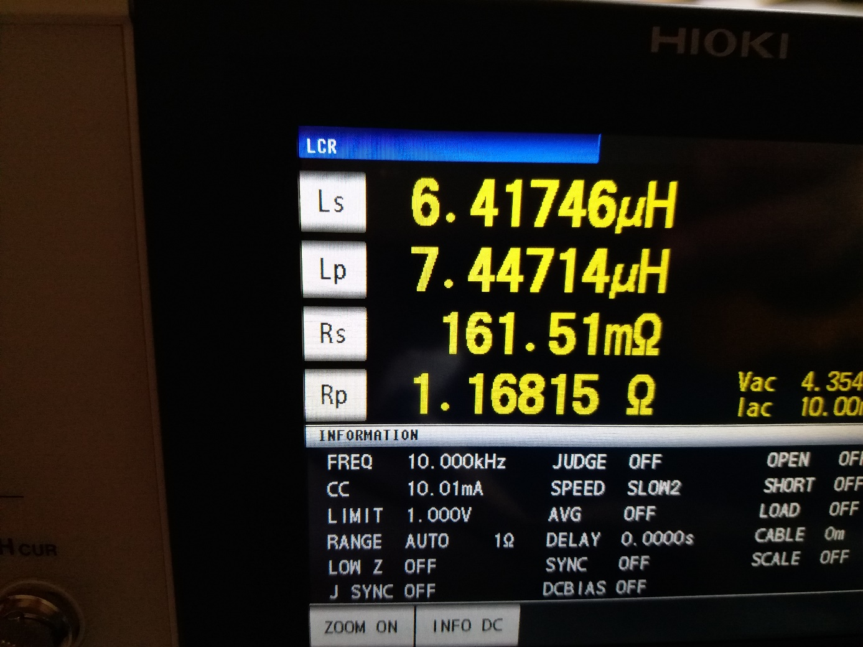

Figure 5. Leakage Inductance of Transformer at Secondary Side

As seen from Figures 4 and 5, leakage inductance increases with square of winding number as expected.

Also we observed that bigger leakage inductance on transformer causes more loss since it increases the voltage on snubber resistance. Output voltage of system change with this loss at constant duty circle. The simulation results of low inductance and high inductance are given as follows;

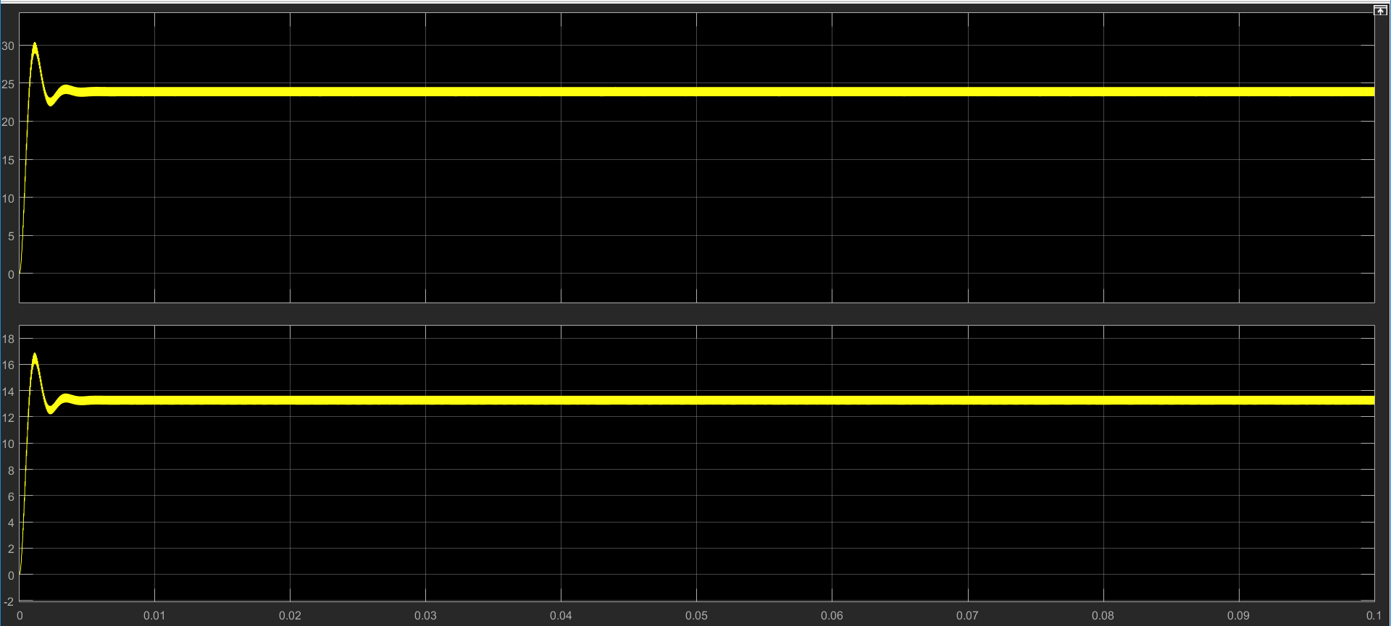

Figure 6. Output Current and Voltage at Low Leakage Inductance at 40% Duty Cycle

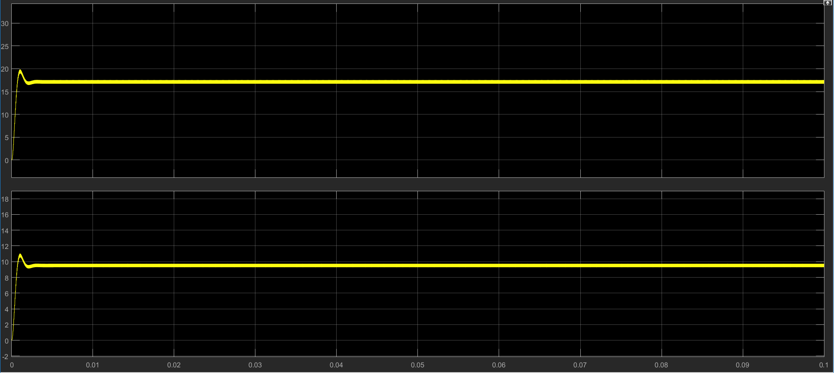

Figure 7.Output Current and Voltage at Normal Leakage Inductance at 40% Duty Cycle

As seen from Figures 6 and 7 voltage and current decreased with increasing leakage inductance. For decreasing leakage inductance, we have to consider winding type.

## Snubber Design

In the project, switching device is MOSFET. In the real life, used transformer is not ideal. This situation causes leakage inductance on the transformer. This can be called inductive load as well. When inductive load is used and switching is made, inductive current is cut suddenly. This sudden cut causes sharp voltage drop on MOSFET.

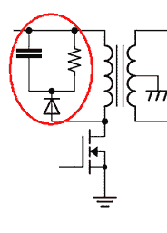

*Figure 8:Schematic of snubber circuit*

To prevent this sharp voltage drop, snubber circuits are used. Snubber circuit provides path for inductive current and prevent to sudden cut on the inductive load. This implies that sudden voltage drop on MOSFET does not occur. When we determine the resistance and capacitance values of snubber circuit, some simulations have been made and then chosen. Now some simulation results will be given. Before simulation with snubber circuit, the simulation will be shared without snubber circuit to show how large voltage drop occurs on the MOSFET.

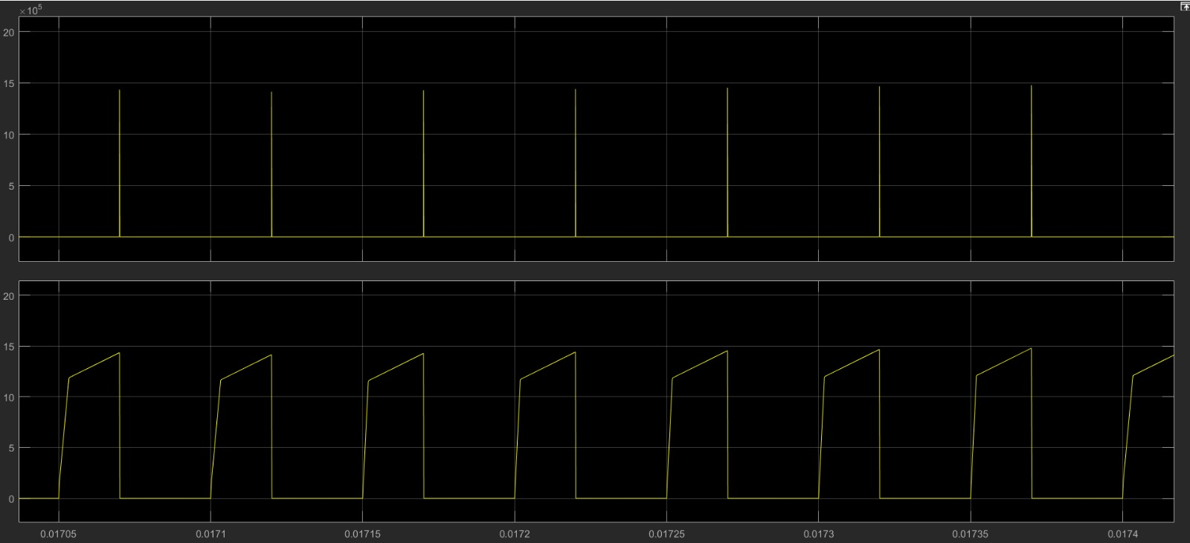

Figure 9: Voltage and current wabeforms of MOSFET without snubber

As can be seen in Figure given above, instantaneous values of voltage drop on MOSFET reaches up to 15000 V. It is hard to handle with this voltage drop and snubber circuit should be used as seen.

Simulation results will be given with 100 ohm and 4.7 mikroFarad, then 250 ohm and 4.7 mikroFarad and finally 560 ohm and 4.7 mikroFarad. By doing this, effect of resistance value will be shown and 560 ohm will be chosen.

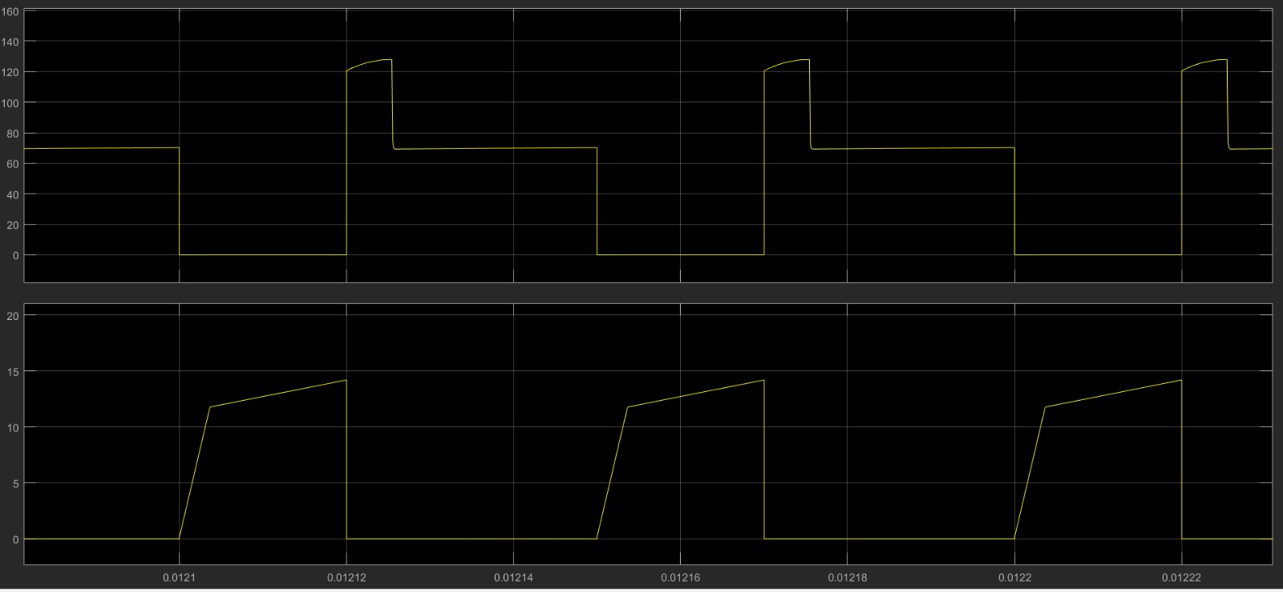

Figure 10: Voltage and current waveform of MOSFET with 100 ohm on snubber

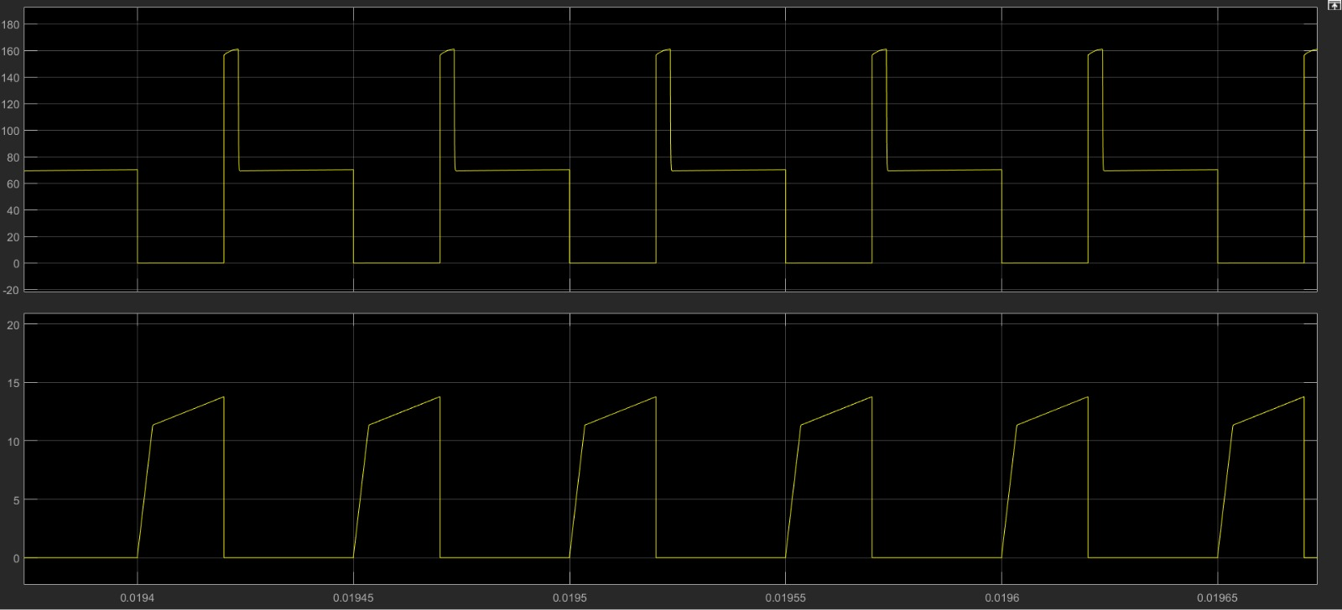

Figure 11: Voltage and current waveform of MOSFET with 250 ohm on snubber

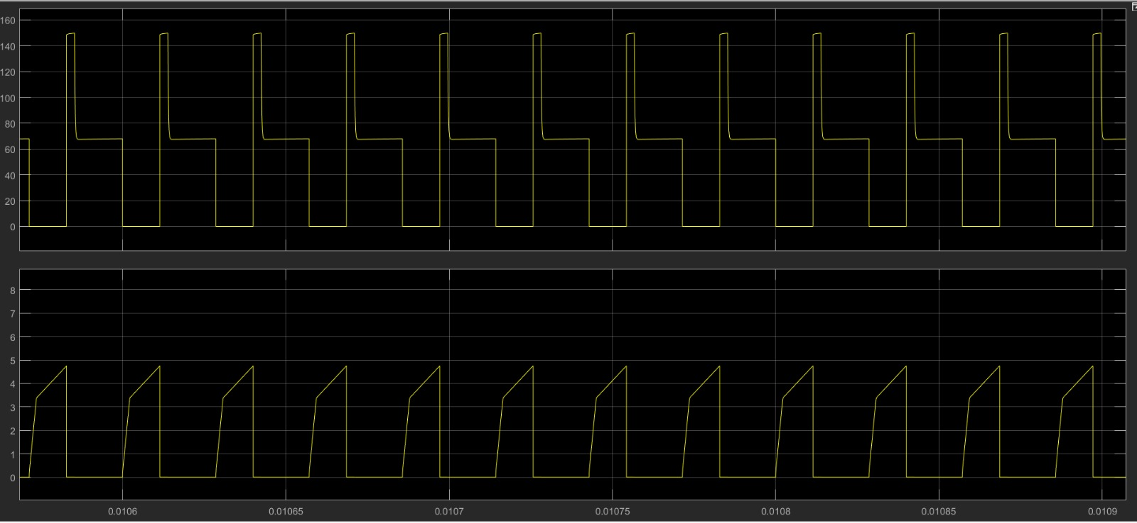

Figure 12: Voltage and current waveform of MOSFET with 560 ohm on snubber

The reason why 560 ohm is chosen is that power loss is at least and snubber voltage is reasonable when 560 ohm is used.

## Controller Design

In our circuit design we used arduino uno as a digital controller. By sensing the output voltage via voltage division with two resistors and analog input of the arduino, we changed the duty cycle of the pwm signal generated in arduino. The sensed voltage is used as feedback signal and a PI controller is used for determination of duty cycle. Kp and Ki values are determined as 0.2 and 10 respectively by trying different values and observing the output in both simulation and real life implementation. Simulation results for different input voltages and test results with the practical circuit are given in the following figures.

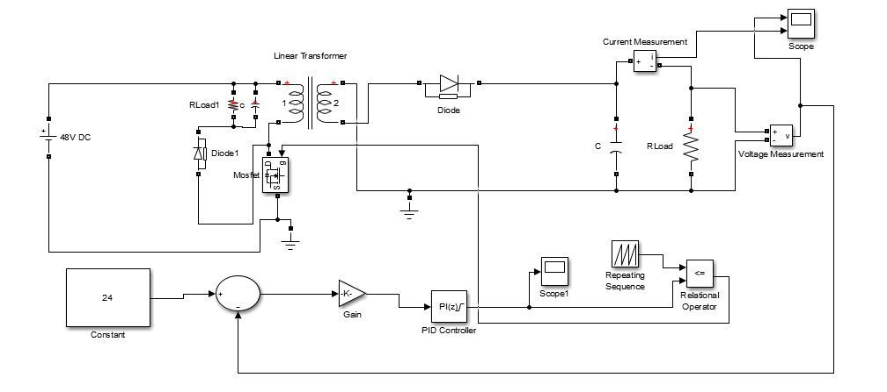

Figure 13: Circuit schematic of the overall circuit with discrete PI controller

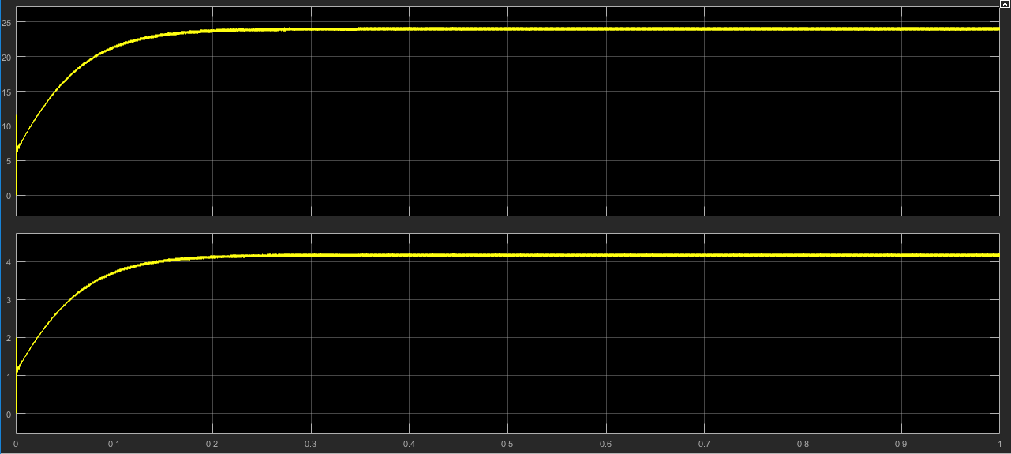

Figure 14: Output voltage and output current when input is 48V

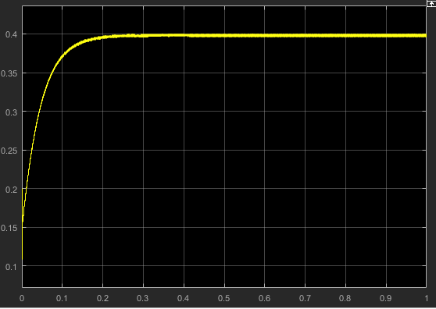

Figure 15: PI controller output which is duty cycle when input is 48V

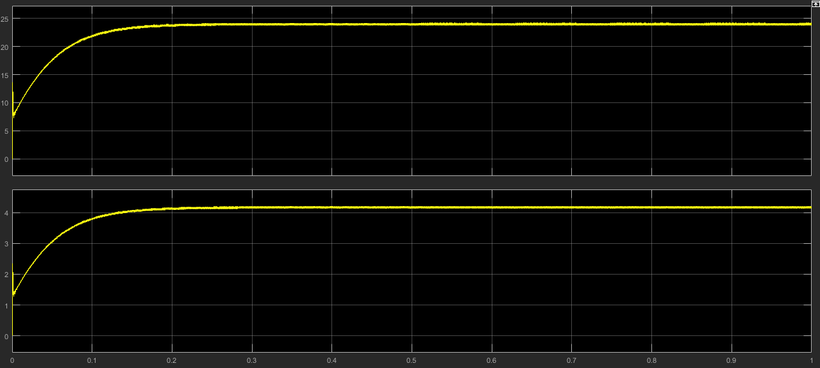

Figure 16: Output voltage and output current when input is 60V

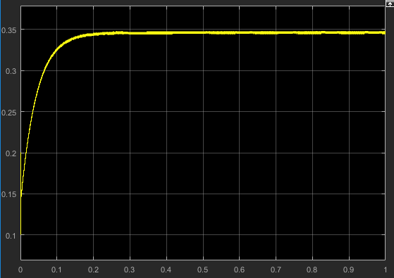

Figure 17: PI controller output which is duty cycle when input is 60V

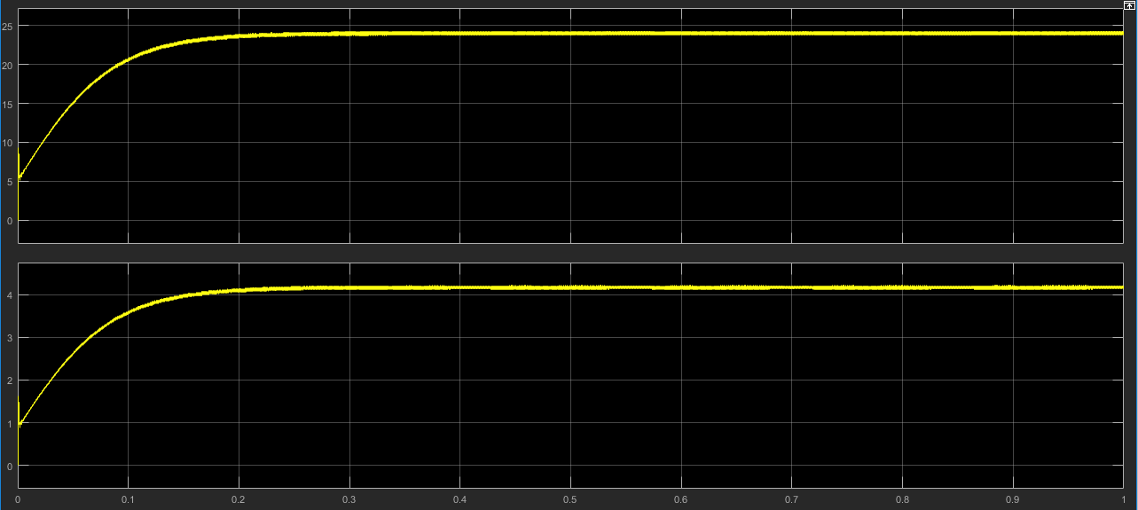

Figure 18: Output voltage and output current when input is 36V

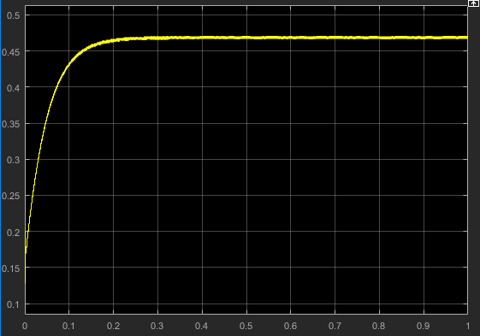

Figure 19: PI controller output which is duty cycle when input is 36V

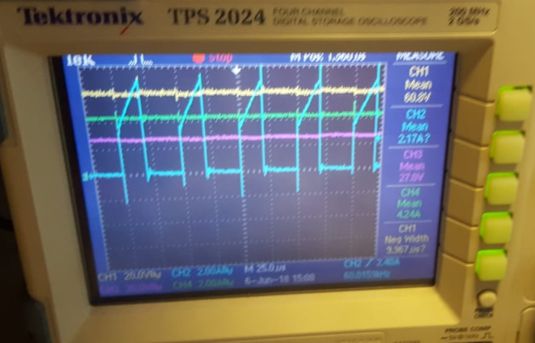

Figure 20: Oscilloscope screen when input is 60V (CH1 input CH3 output)

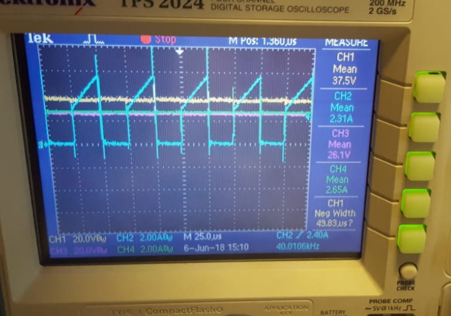

Figure 21: Oscilloscope screen when input is 36V (CH1 input CH3 output)

Output voltages are also observed with a multimeter since there is a mistake of the mean value shown in oscilloscope. The output voltages for 60V input and 36V input is given below.

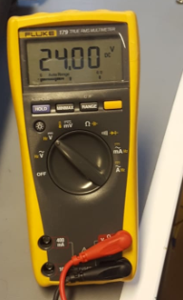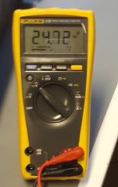  
Figure 22: Output voltage values for 60V input and 36V input respectively

# Component Determination

Before starting to implement the converter, the most important issue is to choose components which will be used. This process is critical in design procedure. Firstly, choosing secondary side diode. For this purpose, simulation results are important to decide rated voltage and current values.

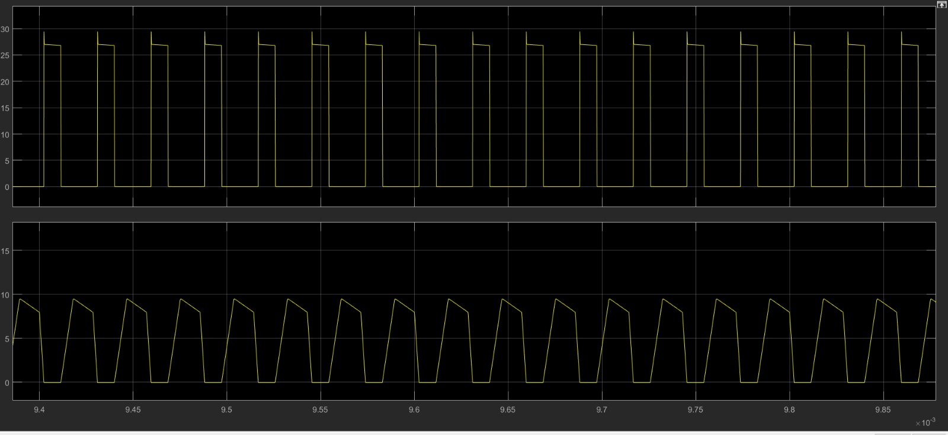

Figure 23:Voltage and current waveform of secondary side diode

Peak values of voltage and current values of diode can be seen in the Figure given above. By inspiring this result, the rated voltage value will be chosen 100V and current value will be chosen 10 A. Beside this, a schotthy diode will be used since opening voltage of these kind of diodes is lower. This brings us closer to the ideal value.

Then choosing of snubber diode will be explained. Its simulation result should be given as well.

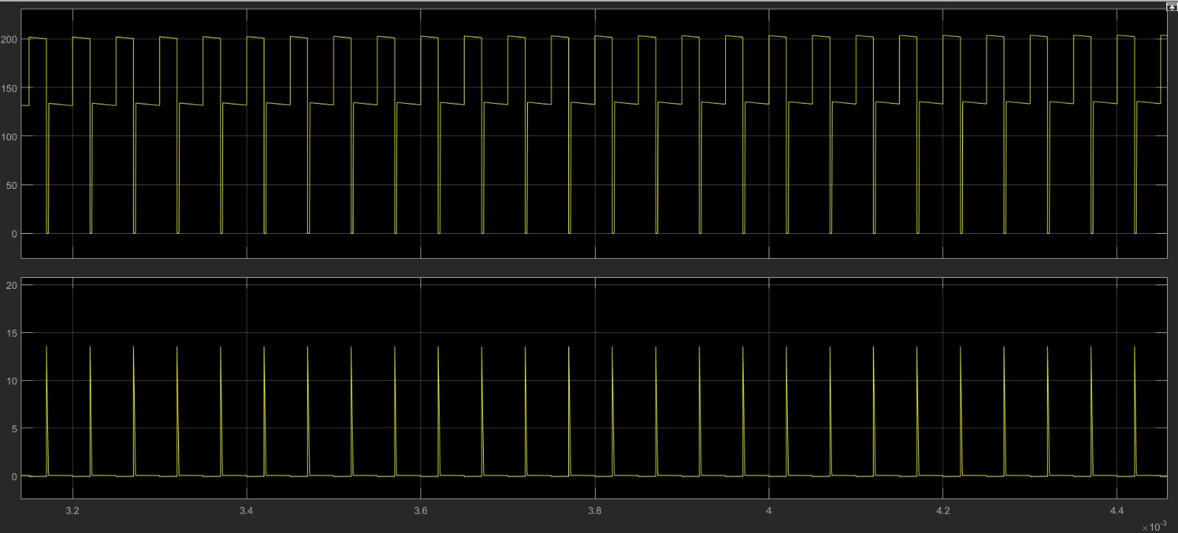

Figure 24: Current and voltage waveform of snubber diode

As seen from the Figure given above, it can be seen the peak values of voltage and current values of snubber diode. According to these values, we choose the specification of diode we use.

Now, choosing the mosfet will be clarified. Its simulation results also will be given.



Figure 25: Current and voltage waveform of mosfet

Its peak values can be seen from Figure given above. The mosfet is chosen with 250V rated voltage and 10A rated current. Its opening voltage is measured as 0.36V.

Other important component is snubber resistance. Its resistance value is chosen 560 ohm and it is mentioned in previous part. Its power rating is 25 Watt.

Rated voltage of output capacitor is chosen according to output voltage and it is determined 100 V.

# Test Results

In this part of report, test results will be given. This results are obtained for four load conditions wich are 25%, 50%, 75% and 100% load. The results will be tabulated and then experimental waveforms will be given (Input and output voltages are measured by 2 external multimeters).

Table 2. Test Results obtained with different loads

|  |  |  |  |  |  |  |  |  |  |  |  |
| --- | --- | --- | --- | --- | --- | --- | --- | --- | --- | --- | --- |
| Load/result | Input voltage(V) | Input current(A) | Output voltage(V) | Output current(A) | P_out(W) | Tmos(C) | Tdiode(C) | Tcap(C) | | Snubber voltage(V) | Effi- ciency (%) |
| 25% | 48.72 | 0.651 | 24.23 | 1.14 | 27.622 | 27 | 27 | | 27.6 | 44.3 | 87.08 |
| 50% | 48.74 | 1.34 | 24.65 | 2.06 | 50.779 | 29 | 30 | | 31 | 46.5 | 77.74 |
| 75% | 48.72 | 1.83 | 24 | 3.01 | 72.24 | 32 | 33 | | 36 | 52.8 | 81.02 |
| 100% | 49.23 | 2.71 | 24.72 | 4.17 | 103.08 | 40 | 35 | | 42 | 60.9 | 77.26 |

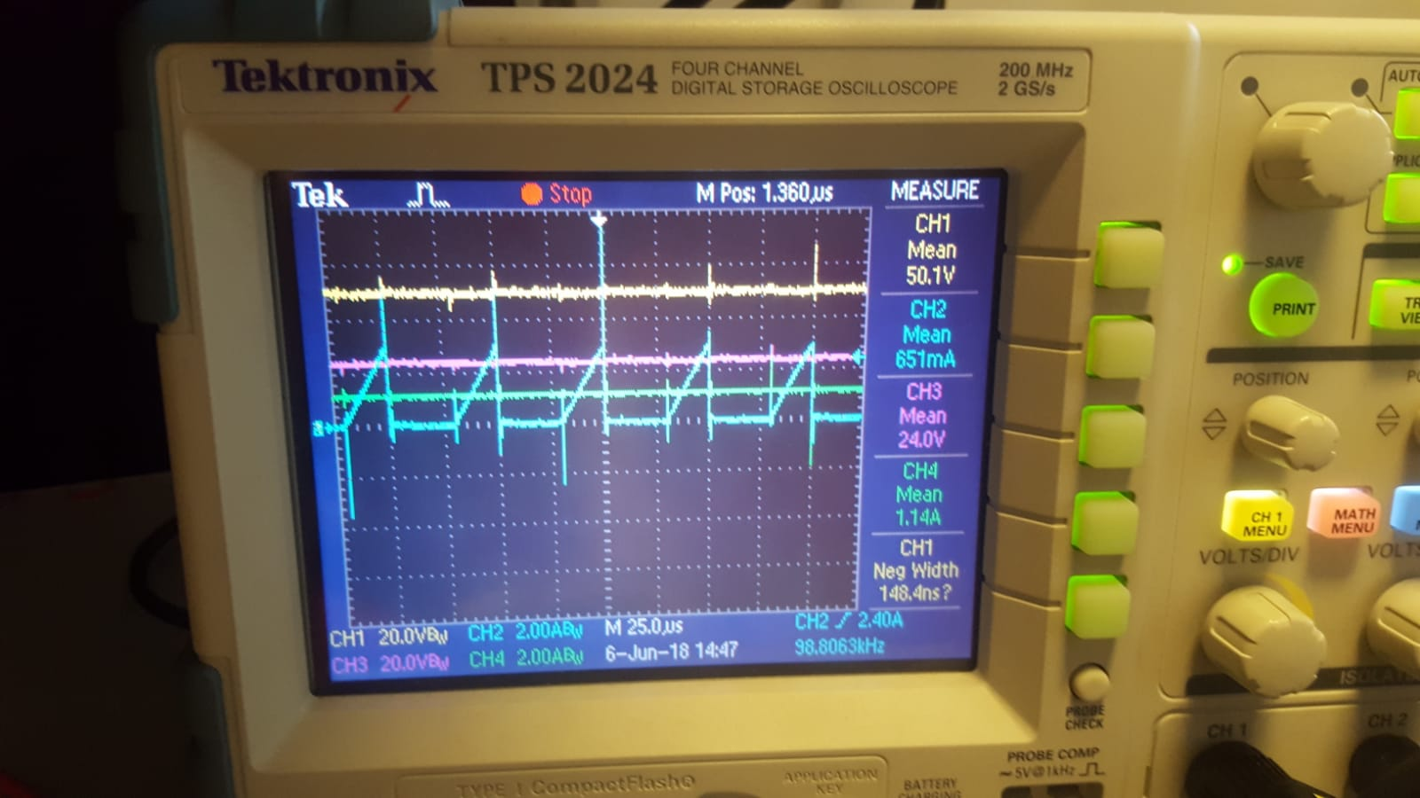

Figure 26: Output voltage & current, input voltage and current waveforms for 25%load

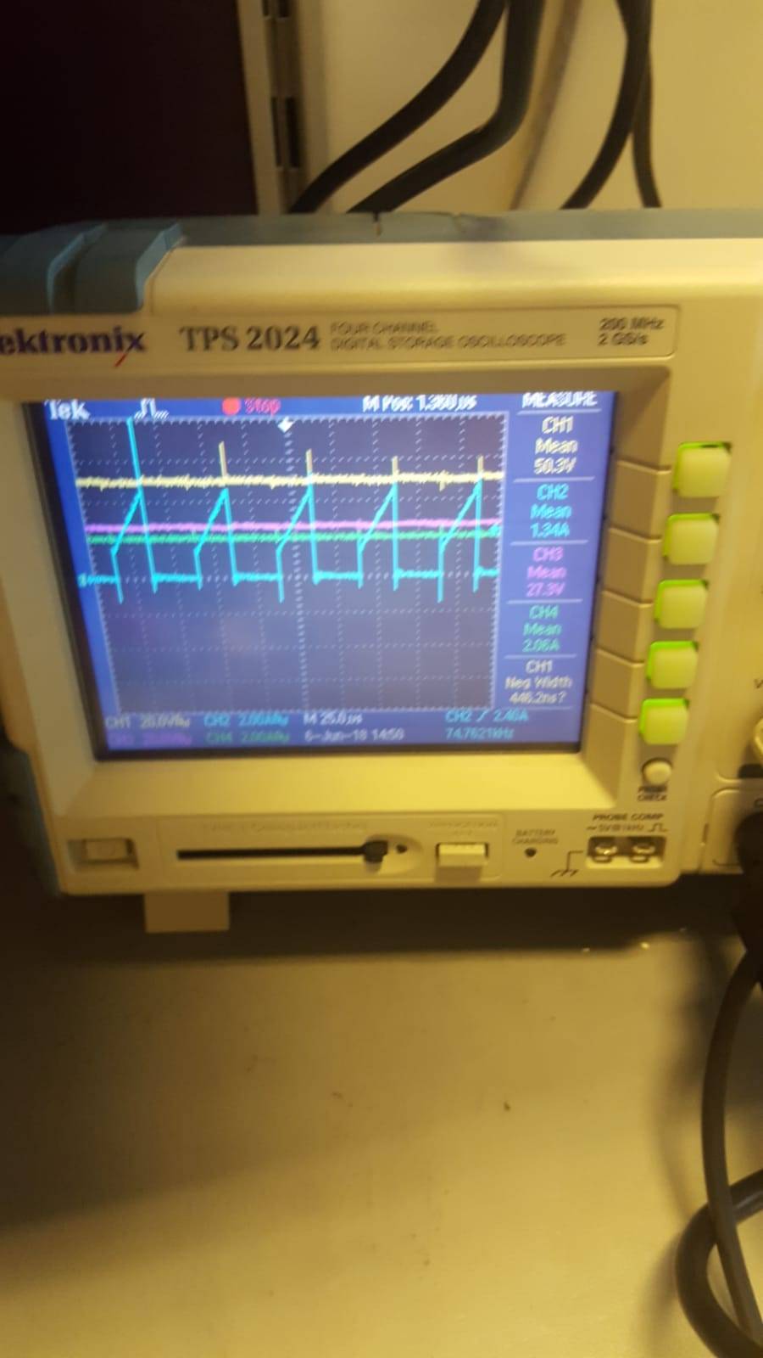

Figure 27: Output voltage & current, input voltage and current waveforms for 50%load

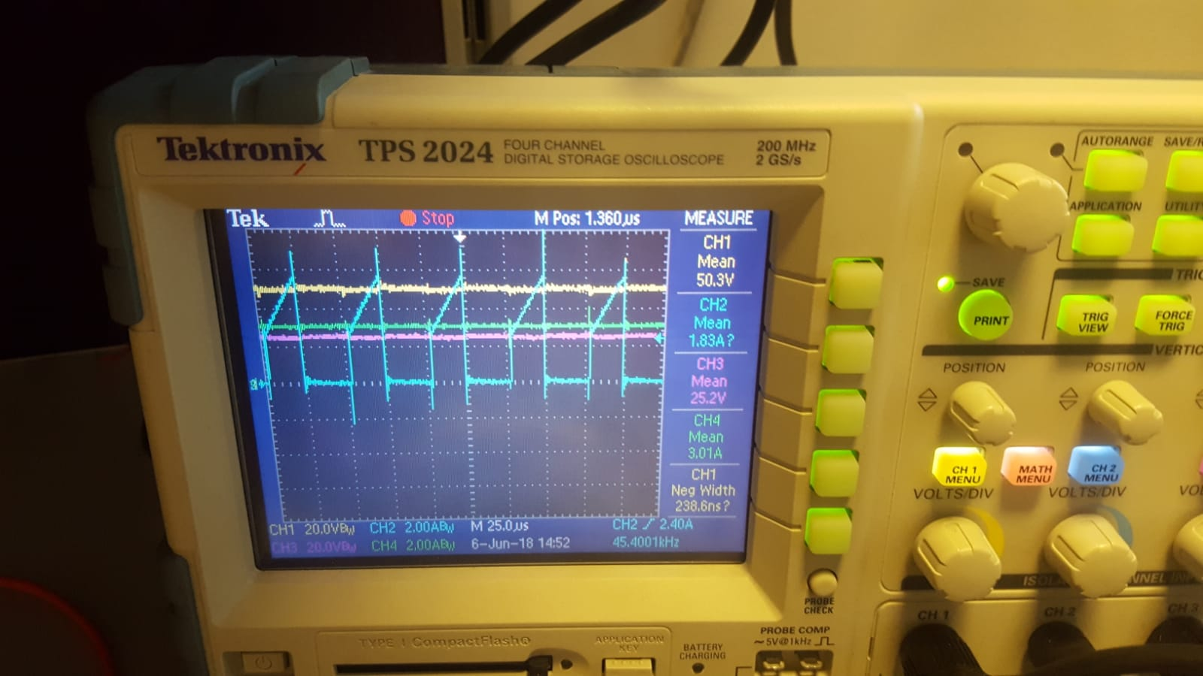

Figure 28: Output voltage & current, input voltage and current waveforms for 75%load

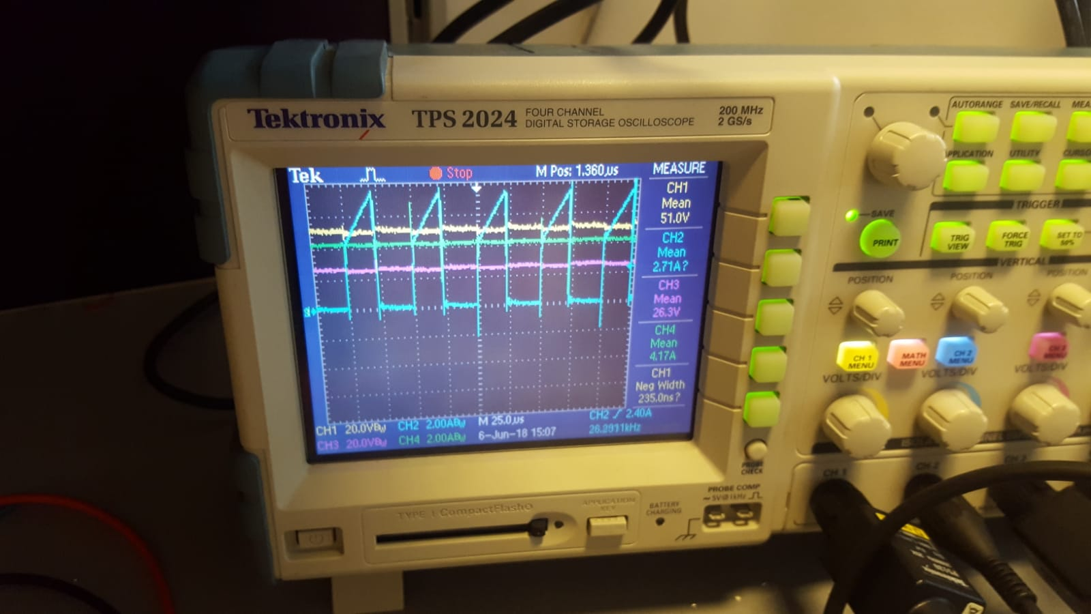

Figure 29: Output voltage & current, input voltage and current waveforms for 100%load

As can be seen from Figures given above, for four different load, measurements are made. As expected, powers and output currents are different while output voltage stays constant. The important difference is the temperature of devices. When higher load is used, temperature of devices increases. The temperature of capacitor is the fastest. On the other hand, yellow waveform is input voltage and blue one is input current. Pink one is output voltage and green one is output current. As can be seen from figure, input current of flyback converter is not continuous due to switching. At the output side, almost DC voltage is obtained with some ripple. Other experimental result is snubber resistor's voltage. Its graph will be given for four loads.

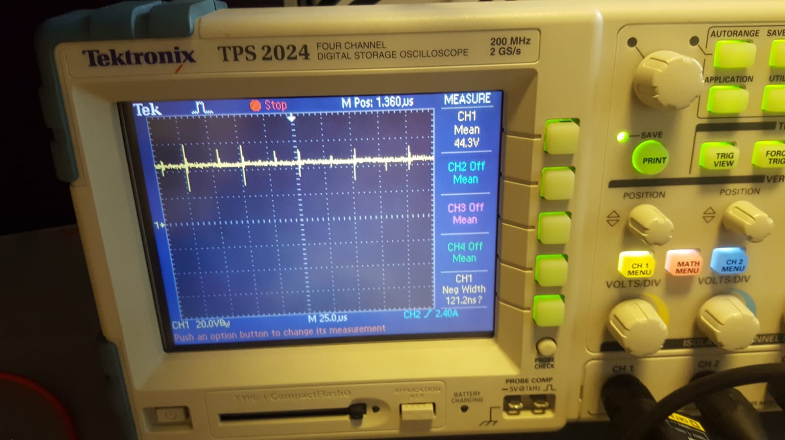

Figure 30:Snubber resistor's voltage for 25% load

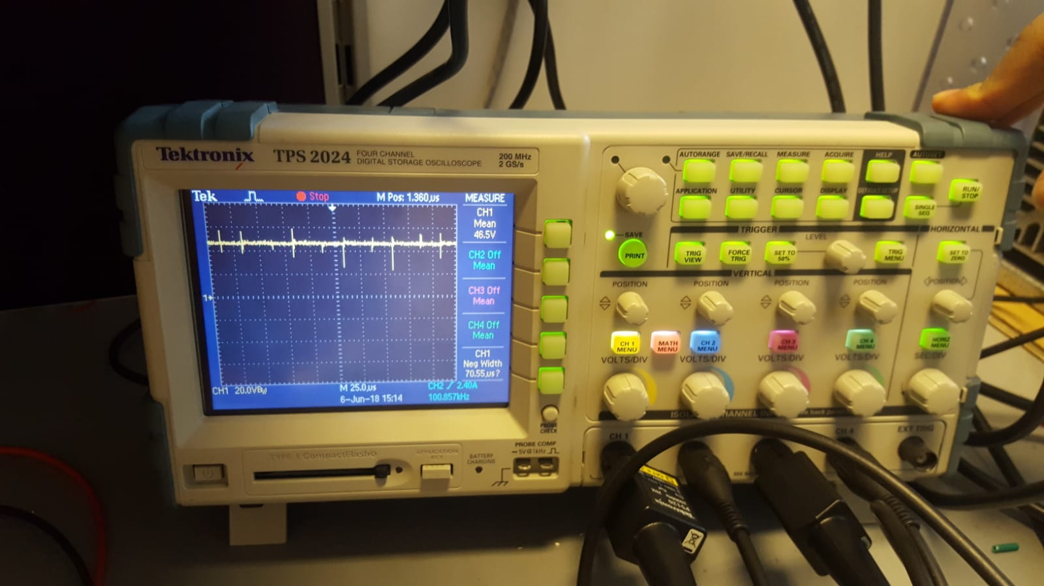

Figure 31:Snubber resistor's voltage for 50% load

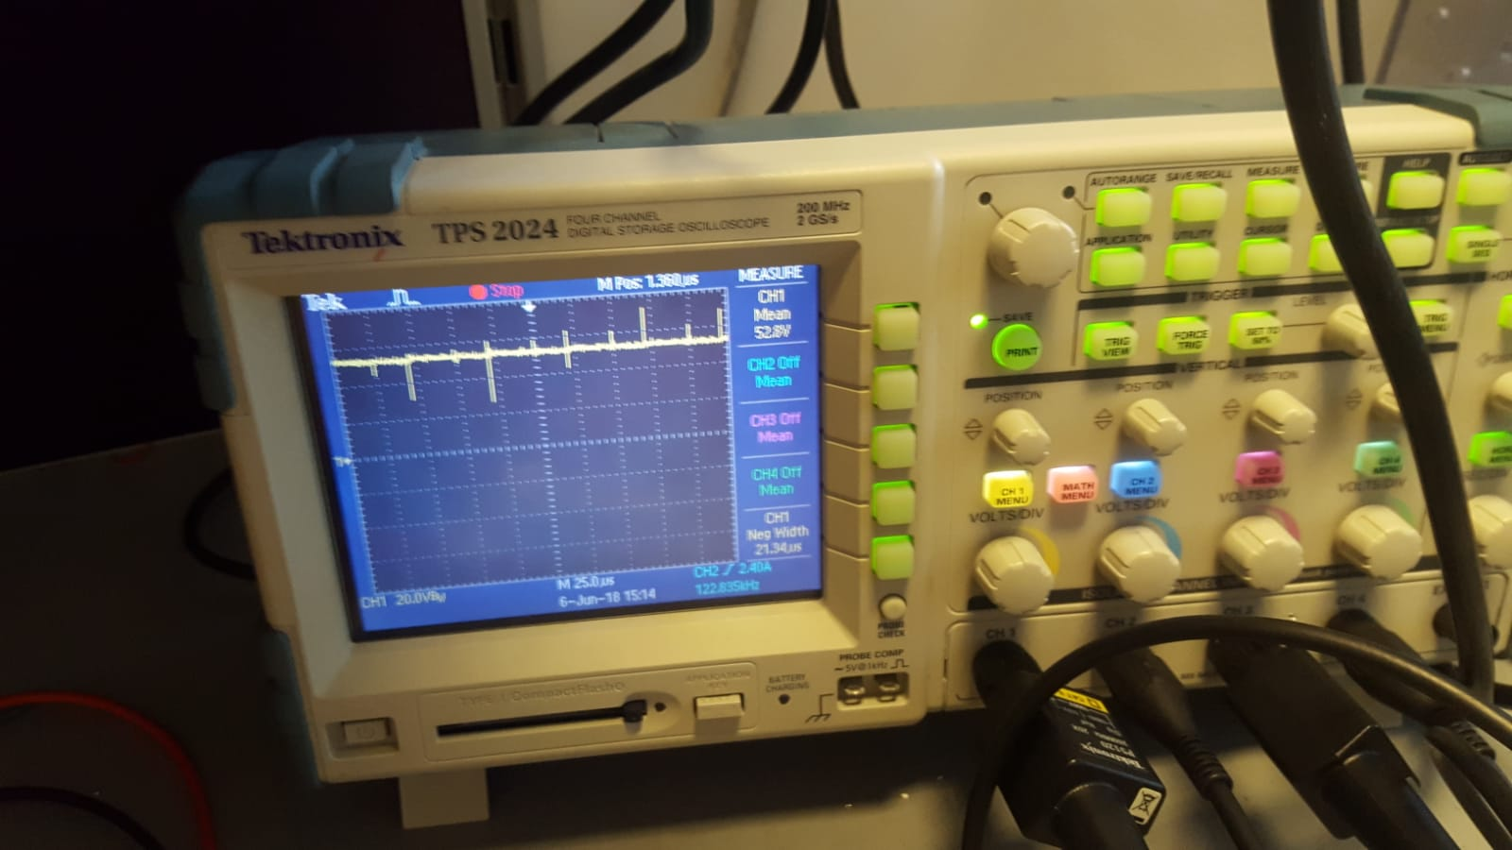

Figure 32:Snubber resistor's voltage for75% load

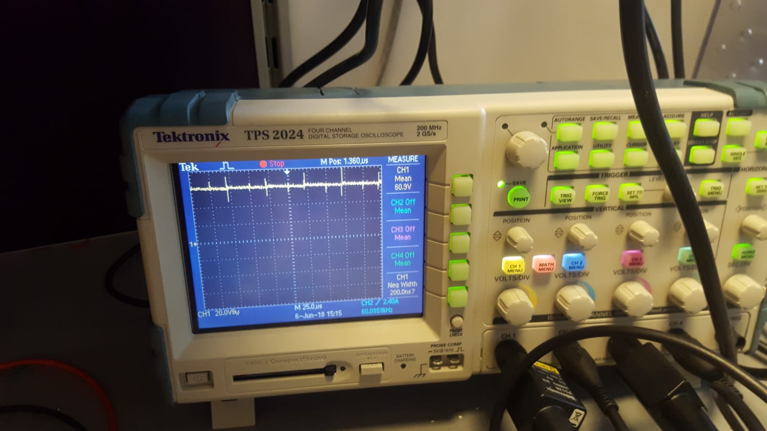

Figure 33:Snubber resistor's voltage for 100% load

As can be seen from Figures given above, snubber voltage increases with increasing load. This increasement implies increasement on power loss on snubber as well.



Figure 34: A view from test measurements (temperature measurement)

# Conclusion

To conclude, this project was very beneficial for us in many ways. First, it gave us the chance to combine the theoretical knowledge gained through the lectures with the practical experience. Also by doing the research in order to design a practical snubber and transformer, we encountered lots of useful information which gave us further perspective about the nature of transformer and the magnetism. In addition to these benefits, we also experienced the inportance of compactness in order to avoid undesirable induced voltages on cables and the effect of the line inductance.